Three Address Code into target machine instructions.

AIM:
To write a C program to implement a simple code generator that converts Three Address Code (TAC) into target machine instructions using MOV, ADD, SUB, MUL, and DIV instructions.
ALGORITHM:
- Start the program.
- Declare variables to store the result, operands, operator, and Three Address Code statement.
- Read Three Address Code statements from the user until END is entered.
- Check whether the statement is an arithmetic operation.
- If it is an arithmetic operation:
- Generate a MOV instruction to load the first operand into a register.
- Use a switch statement to identify the operator.
- Generate the corresponding ADD, SUB, MUL, or DIV instruction.
- Move the result from the register to the destination variable using MOV.
- If the statement is a simple assignment, generate a MOV instruction to copy the value to the destination variable.
- If the statement is invalid, display an error message.
- Repeat the process until END is entered.
- Stop the program.

PSEUDO CODE:
BEGIN

DECLARE result, op1, op2, oper, tac
SET i = 0

DISPLAY "Enter Three Address Code"
DISPLAY "Enter END to finish"

REPEAT

READ tac

IF tac starts with "END" THEN
EXIT LOOP
END IF

IF tac contains an arithmetic expression THEN

EXTRACT result, op1, oper, op2

DISPLAY "MOV R[i], op1"

SWITCH oper

CASE '+':
DISPLAY "ADD R[i], op2"
BREAK

CASE '-':
DISPLAY "SUB R[i], op2"
BREAK

CASE '*':
DISPLAY "MUL R[i], op2"
BREAK

CASE '/':
DISPLAY "DIV R[i], op2"
BREAK

DEFAULT:
DISPLAY "Invalid operator"
STOP
END SWITCH

DISPLAY "MOV result, R[i]"

ELSE IF tac contains a simple assignment THEN

EXTRACT result, op1
DISPLAY "MOV result, op1"

ELSE

DISPLAY "Invalid Three Address Code"

END IF

INCREMENT i

UNTIL END is entered

END

CODE:
#include <stdio.h>
#include <string.h>

int main()
{
char result[20], op1[20], op2[20], oper;
char tac[100];
int i = 0;

printf("Enter Three Address Code:\n");
printf("Enter each statement on a separate line.\n");
printf("Enter END to finish.\n");

while (1)
{
if (fgets(tac, sizeof(tac), stdin) == NULL)
break;

if (strncmp(tac, "END", 3) == 0)
break;

/* Arithmetic instruction */
if (sscanf(tac, "%19s = %19s %c %19s",
result, op1, &oper, op2) == 4)
{
printf("\nTarget Code:\n");
printf("MOV R%d, %s\n", i, op1);

switch (oper)
{
case '+':
printf("ADD R%d, %s\n", i, op2);
break;

case '-':
printf("SUB R%d, %s\n", i, op2);
break;

case '*':
printf("MUL R%d, %s\n", i, op2);
break;

case '/':
printf("DIV R%d, %s\n", i, op2);
break;

default:
printf("Invalid operator\n");
return 1;
}

printf("MOV %s, R%d\n", result, i);
}

/* Simple assignment instruction */
else if (sscanf(tac, "%19s = %19s",
result, op1) == 2)
{
printf("\nTarget Code:\n");
printf("MOV %s, %s\n", result, op1);
}
else
{
printf("Invalid Three Address Code\n");
}

i++;
}

return 0;
}

INPUT:
t1 = b + c
a = t1
END
OUTPUT:
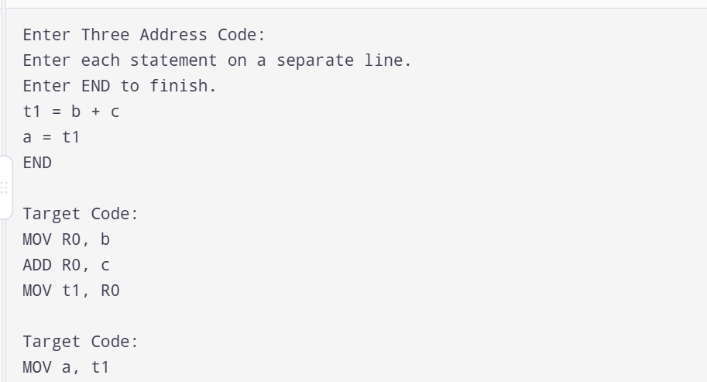

RESULT:
Thus, the C program to implement a simple code generator was successfully executed. The program converts Three Address Code into equivalent target machine instructions using MOV, ADD, SUB, MUL, and DIV instructions.

